|  |
| --- |
| 新东方在线英语学习 |
| 新概念 1 册 |
| Lesson41-42 |

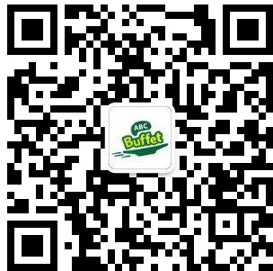

扫一扫。更多有趣的英语资讯。

1. cheese: 奶酪

笑音 \ i:\ Say cheese!

chi yi zi

1. bread: 面包bu ruai d
2. soap: 肥皂

soup 汤

1. chocolate: 巧克力
2. sugar: 糖（白砂糖）

candy，糖果sugar coat？

Can you sugar coat a little?

你可以稍微委婉一点吗？

1. coffee: 咖啡
2. tea: 茶
3. tobacco: 烟草te bai kou

cigarette 香烟

c ge ruai te

1. Not very. 不是非常… It is not very heavy.
2. 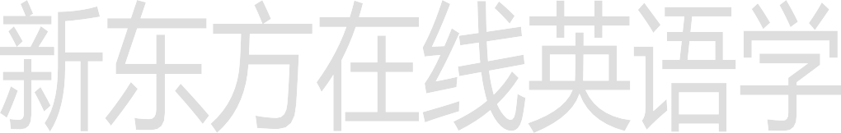What’s in it?

# Lesson 41 单词讲解

**Lesson 41 课文讲解**

What’s on \ under \ over \ behind it？

1. 量词:

a piece of… 一片、一块的…

a loaf of… 一个、一条的…

a bar of… 一条、一块的… a bottle of… 一瓶的…

a pound of… 一磅的…pai 哦 n d

a tin of… 一罐的… a cup of…

a box of…

a spoon of…

1. pound:
   1. ￡英镑

one pound \ two pounds

penny: 便士,one penny \ two pence pan ni pan si

五角 ≈ fifty pence dollar: ＄美元

one dollar \ two dollars

cent: 美分,one cent\ two cents

* 1. a pound: 一磅

one pound ≈ 0.454 kilogram（千克 \ 公斤）

a pound of cheese: 一磅奶酪

Her weight is under ninety pounds.

她的体重不足 90 磅。（90 磅 ≈ 40.86 公斤） 半磅：half a pound of..

四分之一磅：a quarter of a pound of…kao der

# Lesson 41 语法讲解

名词

* + 1. 冠词+名词
    2. 名词所有格:‘s \ of
    3. 单&复数
    4. 可数&不可数不可数名词

1. 概念：不可以数的、不可以计算的名词；
2. 包括：
   1. 液体状的东西；water\ tea\ coffee\ milk\ beer…
   2. 物质名词；soap\ bread\ chocolate\ rice\ tobacco…
   3. 抽象名词. love\ friendship\ work\ homework…
3. 用法：

A. 前面不可以加 one, two, three…

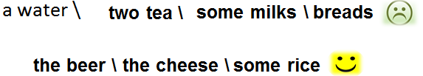

1. 前面不可以加 a\an;
2. 后面不可以加 s，永远是单数。
3. 与量词的搭配：

a piece of bread 一片面包

a loaf of bread 一个面包

a bar of soap 一条肥皂

a bottle of cola 一瓶可乐

a pound of… 一磅的…

a tin of cola 一罐可乐

a cup of coffee 一杯咖啡

a box of tea 一盒茶叶

a spoon of sugar 一勺糖

1. There some bread on the table.

A. is B. are

1. I am thirsty. Would you bring me ,please?

A. some waters B. some tea

C. some soups D. some eggs

1. There two bars of soap in the bathroom.

A. is B. are

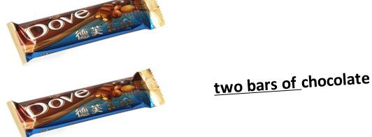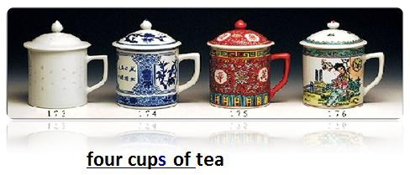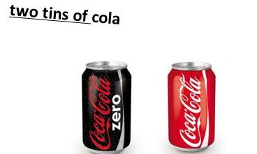

# Lesson 42 单词句型讲解

1. bird: 鸟
2. any: 一些
3. some: 一些
4. some \ any+ 复数名词或不可数名词时, “一些”, some 用在肯定句中, any 用在否定、疑问句中； some students \ some water \

Is there a + ? Is there any+ ?

1. 但在表请求、建议的疑问句中用 some； Could you lend me some money?
2. some

any+ 单数名词，some 翻译为 “某一”，any 翻译为 “任一”。Some day, he can be someone. 某一天,他可能成为个人物。You can buy it in any supermarket.

你可以在任何一个超市买到。

# Lesson 41&42 知识拓展

2. 读法:

￡3: three pounds

＄5: five dollars

€ 7: seven euro

￡0.9: ninety pence

＄0.3: thirty cents

￡10.5: ten fifty pounds

＄15.8: fifteen eighty dollars

€ 24.65: twenty- four sixty five euro

￡120: one hundred and twenty\ one twenty pounds